Moon: Copernicus Crater

Exploration:

Lunar Rovers: Visitors can explore the crater's surface using lunar rovers equipped with advanced navigation systems.

Helium-3 Mining Tours: Highlight the Moon's potential as a source of valuable resources by offering tours of mining operations in the crater.

Accommodation:

Underground Moon Base: Create a safe and comfortable underground habitat within the crater, protecting tourists from radiation and extreme temperatures.

Fun Activities:

Low-Gravity Sports: Organize low-gravity sports like lunar golf, lunar skiing, or even trampoline parks.

Astronomical Observatories: Take advantage of the Moon's lack of atmosphere to offer unparalleled stargazing experiences.



lunar rovers on mars with people

FINAL RESULTS: next page

\*\*Explore the Moon's Wonders: Copernicus Crater\*\*

Welcome to Copernicus Crater, an extraordinary lunar destination where the Moon's mysteries await your exploration. Get ready for an out-of-this-world adventure that combines science, exploration, and relaxation!

\*\*Exploration\*\*

\*Experience Lunar Rovers\*

Step onto the lunar surface and embark on a journey like no other. Our state-of-the-art lunar rovers, equipped with advanced navigation systems, will take you on an unforgettable tour of Copernicus Crater. Traverse the rugged terrain and discover the Moon's hidden gems.

\*Helium-3 Mining Tours\*

Delve into the Moon's potential as a valuable resource hub. Join our Helium-3 Mining Tours to witness cutting-edge mining operations right here in the crater. Learn about the future of lunar resource utilization and its significance for space exploration.

\*\*Accommodation\*\*

\*Underground Moon Base\*

Rest in comfort and security within our Underground Moon Base. Nestled beneath the lunar surface, this innovative habitat shields you from radiation and extreme temperatures. Experience a peaceful night's sleep while surrounded by the Moon's tranquility.

\*\*Fun Activities\*\*

\*Low-Gravity Sports\*

Feel the thrill of low-gravity sports as you engage in activities like lunar golf, lunar skiing, or even bouncing on our lunar trampolines. Challenge your friends and family to these exhilarating experiences, all with the Moon as your playground.

\*Astronomical Observatories\*

Take advantage of the Moon's unique lack of atmosphere to gaze upon the cosmos like never before. Our state-of-the-art astronomical observatories provide unparalleled stargazing opportunities. Marvel at the beauty of distant galaxies, stars, and celestial phenomena.

Join us at Copernicus Crater and become a part of lunar history. Unearth the Moon's secrets, bask in its serene landscapes, and indulge in unforgettable adventures. Your lunar odyssey begins here!

g

gaze the cosmos(last page)

GOLF ON MOON:



Visit spaceship labs :

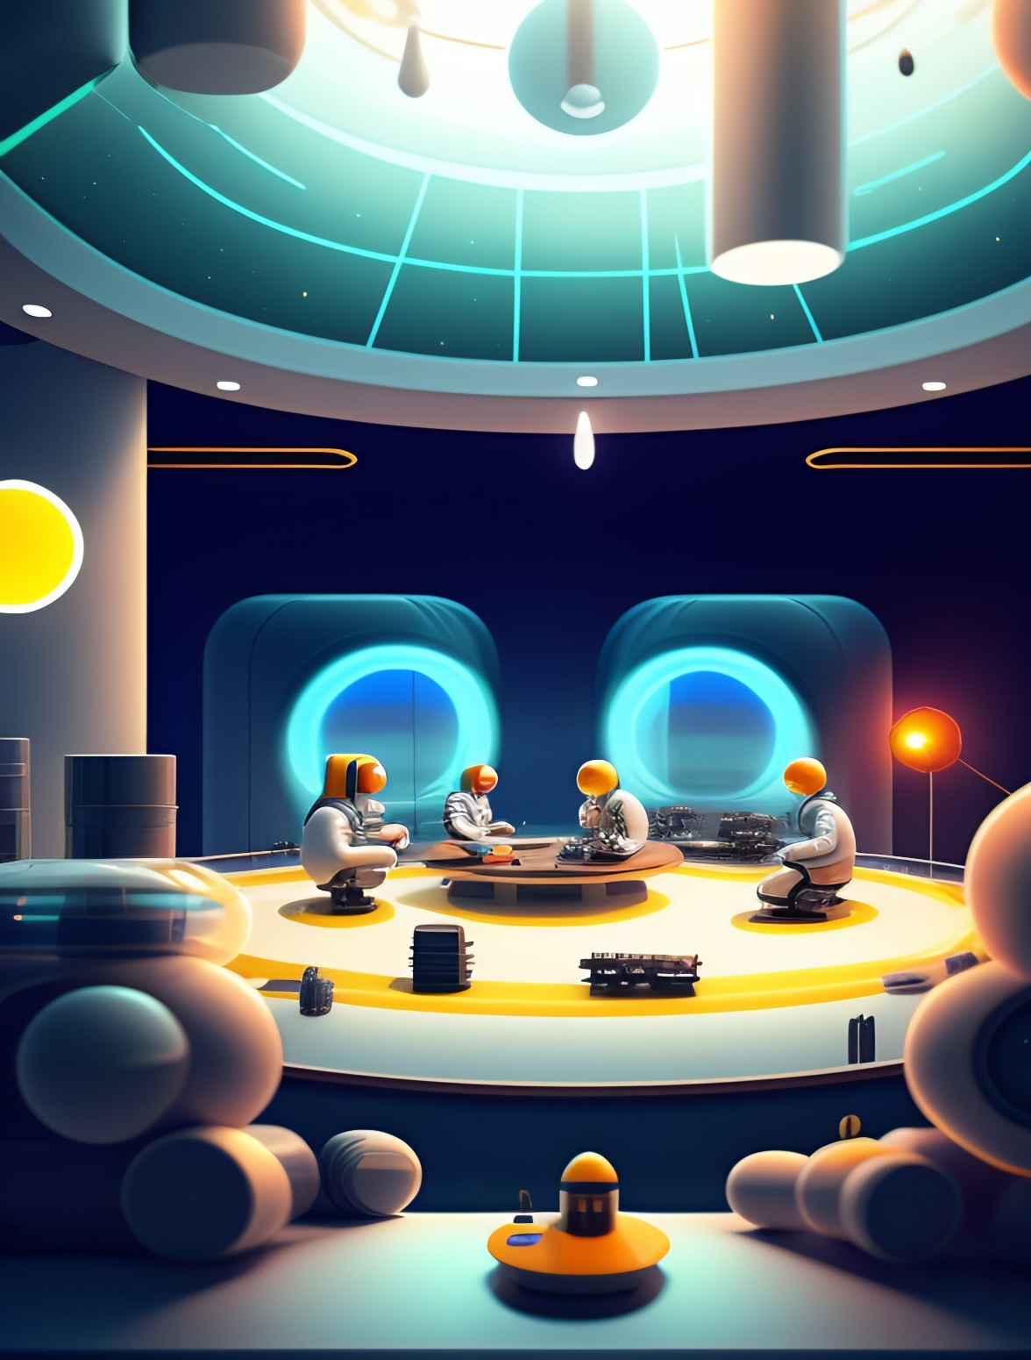

What Sets Us Apart

Scientific Significance: Copernicus Crater is renowned for its geological and scientific significance. Explore its impact basin and gain insights into lunar history.

Innovative Accommodations: Our Underground Moon Base is a testament to innovation, offering a safe and comfortable haven beneath the lunar surface.

Exclusive Activities: Engage in low-gravity sports and stargazing experiences that are unique to Copernicus Crater, making your lunar journey truly exceptional.

Join us at Copernicus Crater and become a part of lunar history. Unearth the Moon's secrets, bask in its serene landscapes, and indulge in unforgettable adventures. Your lunar odyssey begins here!